Calculation Guidance- Addition
 | Object | Concrete | Pictorial | Abstract
Year 1 | Represent number bonds | 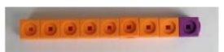  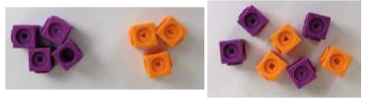  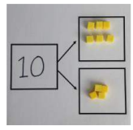  Use cubes to add two numbers together. Represent on part-whole model | 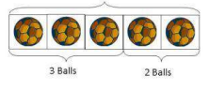  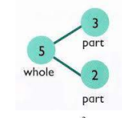    Represent on bar model and part-whole model. | 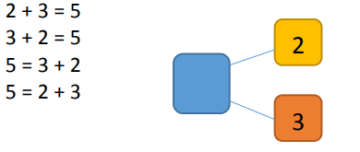  Use part-whole model to move into the abstract.
Year 1 | Addition to 20 | 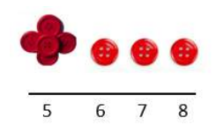  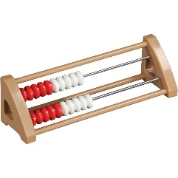  Start with the biggest number and count on. | 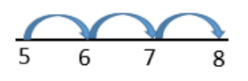  Use of number lines. | 5 + 3 = 8  Place the larger number in your head and count on.
Year 1 | Making 10 | 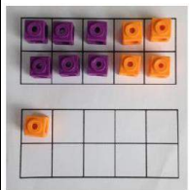  6 + 5 = 11  Use of tens frame to visualise 10. | 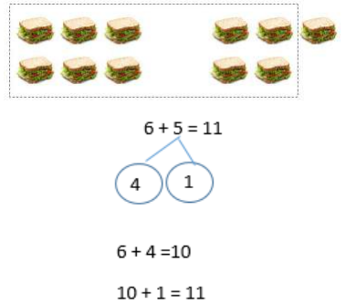  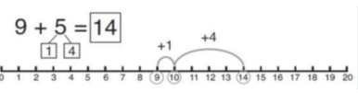 | 7 + 4= 11  ‘If I am at seven, how many more do I need to make 10. How many more do I add on now?’
Year 2 | Adding 3 numbers | 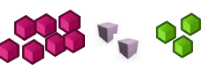  Try to make 10 first, then add the extra digit. | 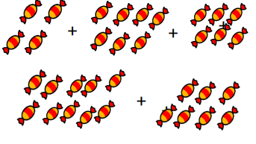  Draw pictures to recombine to make 10. | 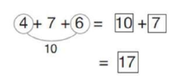
Year 2 | Addition- 2 digits add ones | 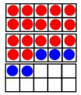  Use tens frames to make 10. | 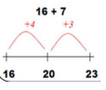  Using number lines. | 17 + 5 = 22
Year 2 | Addition- 2 digits add tens | 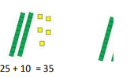  Explain the ones do not change. | 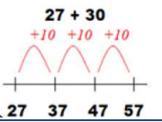 | 27 + 10 = 37  27 + 20 = 47  27 + □ = 57
Year 2 | Addition- 2 digit add 2 digits | 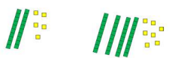 | 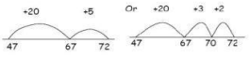  Use of number lines. | 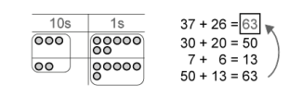  Pupils do not need to learn formal written methods for addition and subtraction, but column addition could be used as an alternative way to record two-digit calculations. For calculations such as 26 + 37 , pupils can begin to think about the 2 quantities arranged in columns under place-value headings of tens and ones.
Y2 | Use known number facts | 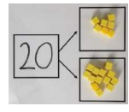  Using number up to 20 | 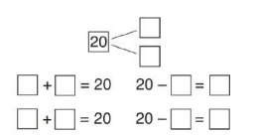 | 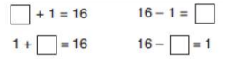
Y3 | Column addition- no regrouping | 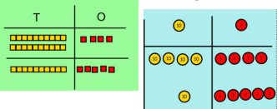  Use base 10, before moving onto place value counters. | Draw the counters onto a place value grid.  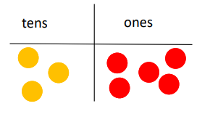 | 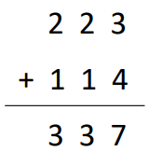  Add ones, tens and hundreds.
Y3 | Column addition- regrouping | 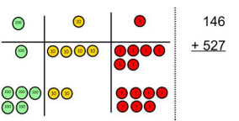  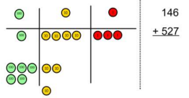  Exchange ten ones for a ten. | 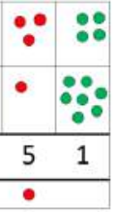  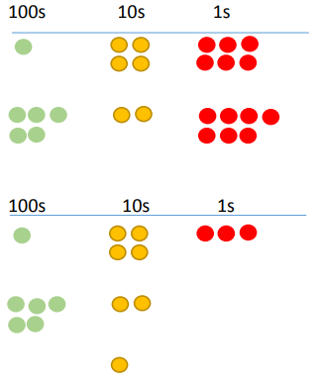  Children can draw a representation of the grid to further support their understanding, carrying the ten underneath the line. | 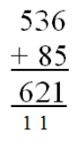
Y4 | Add numbers up to 4 digits | 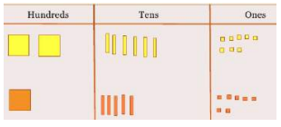  Exchanging ten tens for a hundred and ten hundreds for a thousand. | 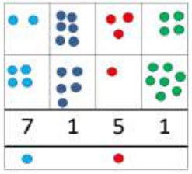 | 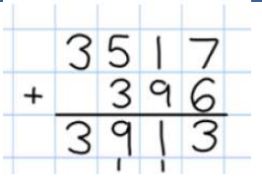
Y5 | Add numbers with more than 4 digits. Add decimals with 2 decimal places, including money. | 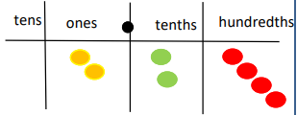  Introduce decimal place value counters and model exchange for addition. | 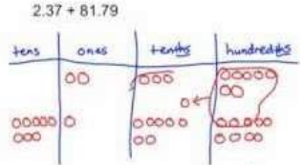 | 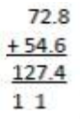
Y6 | Add several numbers of increasing complexity |  |  | 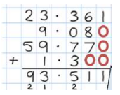Insert zeros for placeholders.

Subtraction
 | Objective | Concrete | Abstract | Pictorial
Y1 | Taking away ones | 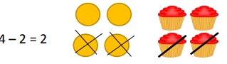  Using physical objects and cubes. | 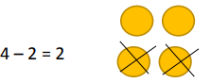  Cross out objects to show they have been taken away. | 4 – 2 = 2
Y1 | Counting back | 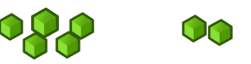  Moving objects backwards. | 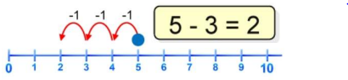  Count back in ones using a number line. | Put 13 in your head, count back 4. What number are you at?
Y1 | Find the difference | Build towers to find the difference with cubes.  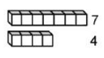 | 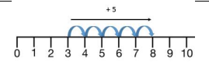  Count on to find the difference. | Hannah has 8 goldfish. Helen has 3 goldfish. Find the difference between the number of goldfish the girls have.
Y1 | Number facts within 20 | 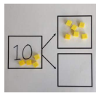If 10 is the whole and 6 is one of the parts, what is the other part? | 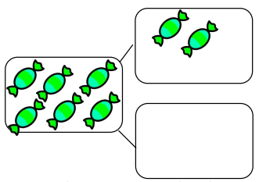 | 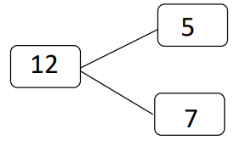Move to using numbers in part-whole model.
Y2 | Subtract without regrouping | 34—13 = 21 Use tens frames to show how to partition the number when subtracting without regrouping.  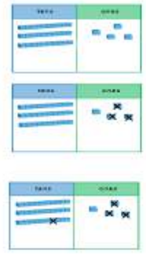 | 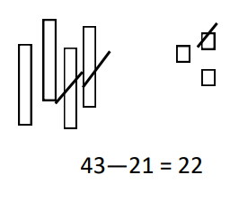  Children draw representations and cross off. | 43—21 = 22
Y3 | Subtract without regrouping | 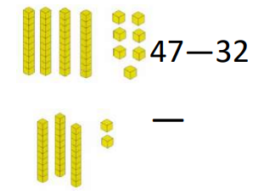 | 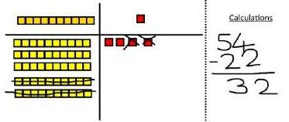  Draw own representations | 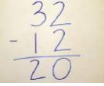
Y3 | Subtract with regrouping | Make the larger number with the place value counters.  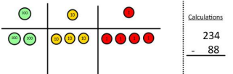  Start with the ones, can I take away 8 from 4 easily? I need to exchange 1 of my tens for 10 ones.  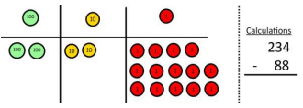  Now I can subtract the ones. | 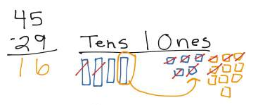  Draw base 10 and cross off. | 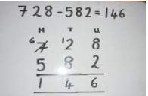
Y4 | Subtract up to 4 digits | 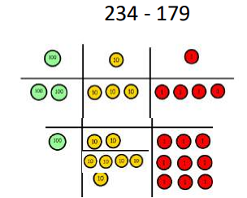  Model with base 10/counters | Draw counters and show the exchange. | 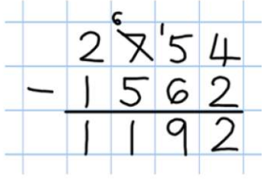
Y5 | Subtract with money and measures |  |  | 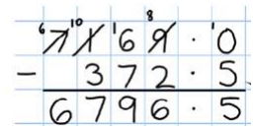
Y6 | Subtract with increasingly large and more complex numbers and decimal values. |  |  | 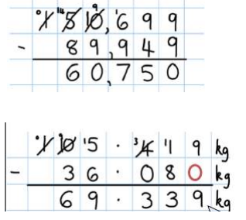

Multiplication
 | Objective | Concrete | Pictorial | Abstract
Y1 | Doubling | 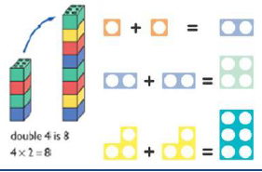  Doubling using blocks and Numicon | 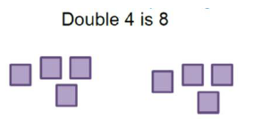  Drawing pictures to double | Double 3 = 6  Double 2 = 4
Y1 | Repeated addition | 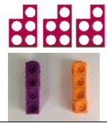 | 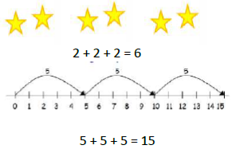 | 2, 4, 6, 8, 10  5, 10, 15, 20, 25 , 30  2 + 2 + 2 =
Y1 | Arrays | 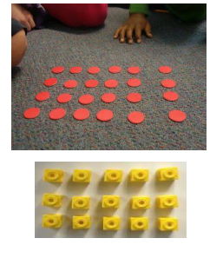  Use practical equipment to make arrays. | 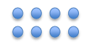  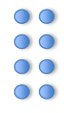  Draw arrays in different rotations to explore commutativity. | 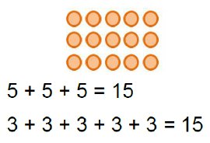  Use an array to  reinforce repeated  addition.
Y2 | Doubling | 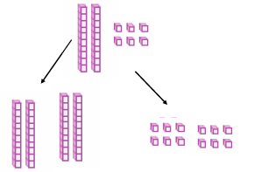  Model using tens and ones. | Draw pictures and representations to  show how to double numbers | 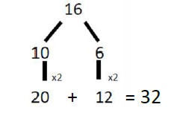  Partition a number first before doubling each part and recombining it back.
Y2 | Counting in multiples  of 2, 3, 4, 5, 10  from 0  (repeated addition) | 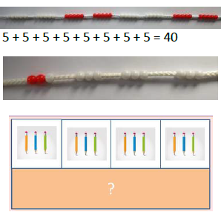  Skip counting with models. Use of bar model. | 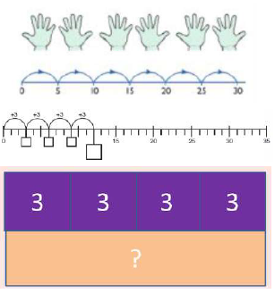  Number lines, counting sticks and bar models. | 0, 2, 4, 6, 8, 10  0, 3, 6, 9, 12, 15  0, 5, 10, 15, 20, 25 , 30  4 x 3 =
Y2 | Arrays | As multiplication is commutative, the order of  the multiplication does not affect the answer.  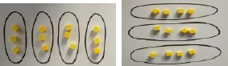 | 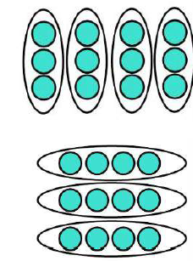 | 4 x 3 =  3 x 4 =
Y3 | Grid method | Show the link with arrays to the first  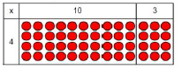  introduce the grid method.  4 rows of 10  4 rows of 3  Move onto Base 10  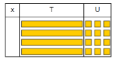  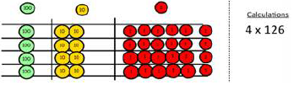  Move onto place value counters  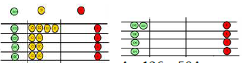  Exchange by starting with the ones | Draw counters for the grid method  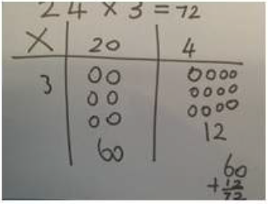 | Multiply with one-digit  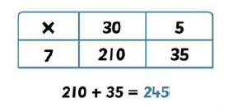
Y4 | Column multiplication | 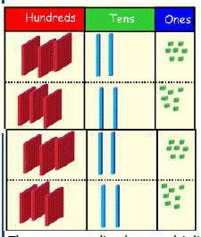 | 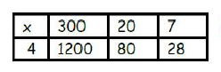 | 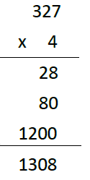
Y5 | Long multiplication and compact method | Use of place value counters if needed | 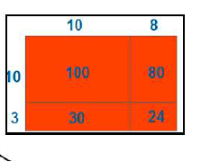 | 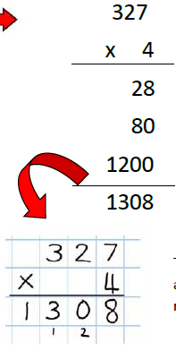  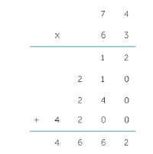  Moving onto 2 digits
Y6 | Long multiplication and compact method |  |  | 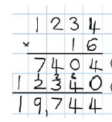
Y6 | Decimals |  |  | 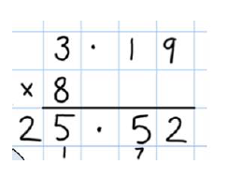

Division
 | Objective | Concrete | Pictorial | Abstract
Y1 | Division as sharing | 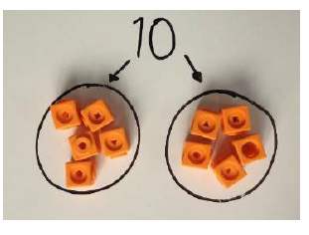 | 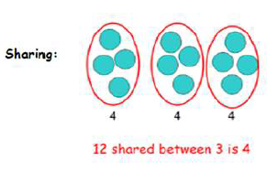 | 12 shared between 3 is 4
Y2 | Grouping | 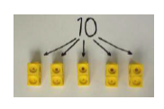 | 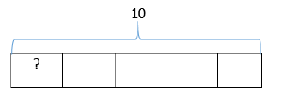  Using bar model | 10 ÷ 5 = 2
Y2 | Division with arrays | 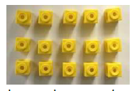  Write matching number sentences.  15 ÷ 3 = 5  5 x 3 = 15 | 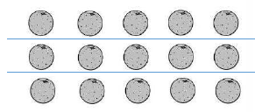  Use lines to split the array. | 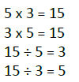  Write the four linked number sentences.
Y3 | Grouping | 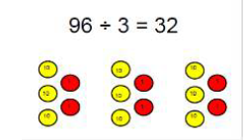  Use of place value counters | Bar modelling  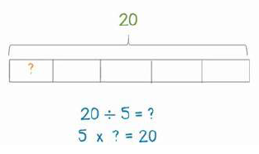 | 26 ÷ 6 = 4
Y3 | Short division | 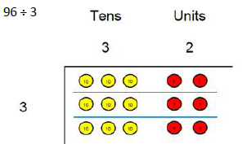  96 ÷ 3 =  Split 96 into 3 groups with tens and ones place value counters.  Move onto harder divisions  42 ÷ 3 =  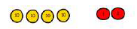  Make 42  Share 40 between 3 groups.  Is left over.  Swap 10 counter for ten ones.  Share the ones into 3 groups. | 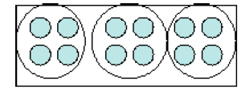 | 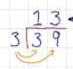  39 ÷ 3 =  No remainders
Y4 | Formal written method | Same as Y3 with 3 digits | Same as Y3 with 3 digits | 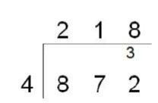  With exact answers
Y5 | Division with remainders | 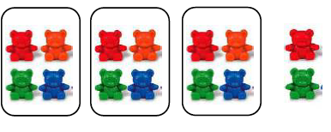 | 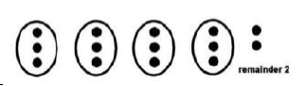 | 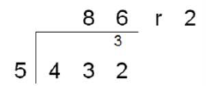
Y6 | Remainders with decimals |  |  | 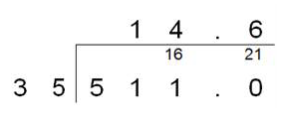  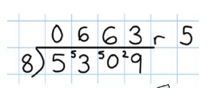  Multiple remainders

